***Karan Singh***

***Narmin Chandiwala***

***College****:* ***Mulund College of Commerce***

***Department of Computer Science***

**Date**:  
***12th May 2025***

**Title:**

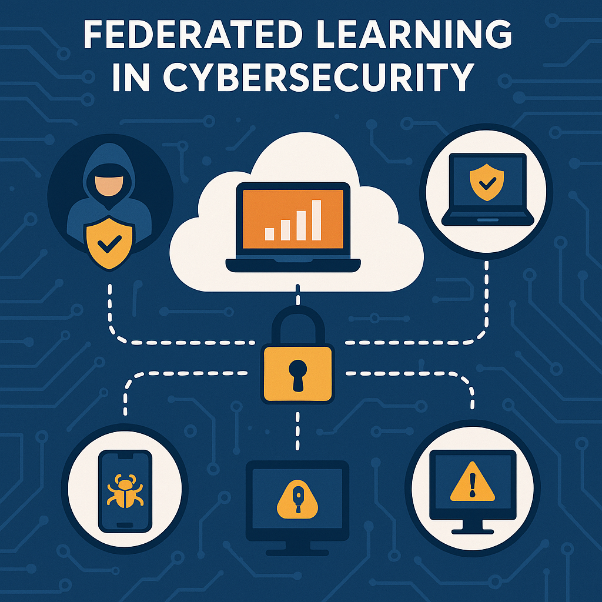

**📄 Abstract**

In the evolving landscape of cybersecurity, the proliferation of malware poses significant threats to digital infrastructures. Traditional centralized malware detection systems often grapple with challenges related to data privacy, scalability, and adaptability to emerging threats. This project introduces a decentralized approach employing **Federated Learning (FL)** to enhance malware detection capabilities while preserving user privacy. By enabling multiple clients to collaboratively train a shared model without exchanging raw data, FL mitigates privacy concerns and reduces the risk of data breaches.

The developed tool simulates a federated learning environment where local models are trained on synthetic datasets representing benign and malicious behaviors. Features such as file entropy, filename length, and simulated system calls are extracted to train a logistic regression model. The aggregated global model is then utilized to predict the likelihood of a file being malicious. Experimental results demonstrate the efficacy of the FL approach in maintaining high detection accuracy while ensuring data confidentiality.

This report delves into the problem statement, literature review, research methodology, tool implementation, results, ethical considerations, market relevance, future scope, and references, providing a comprehensive overview of the project's contributions to the field of cybersecurity.

**🧩 Problem Statement & Objective**

**Problem Statement**

The increasing sophistication of malware attacks necessitates advanced detection mechanisms. Conventional centralized malware detection systems require aggregating vast amounts of user data, raising significant privacy concerns and creating potential single points of failure. Moreover, these systems often struggle to adapt promptly to novel malware variants, especially in decentralized environments like mobile devices and IoT networks.

**Objectives**

* **Develop a federated learning-based malware detection model** that enables decentralized training across multiple simulated clients without sharing raw data.
* **Ensure data privacy and security** by retaining data on local devices during the training process.
* **Achieve high detection accuracy** comparable to centralized models.
* **Design a user-friendly tool** that allows users to input file paths and receive real-time predictions regarding the file's maliciousness.

**📚 Literature Review**

**Federated Learning in Cybersecurity**

Federated Learning (FL) has emerged as a promising paradigm for privacy-preserving machine learning. It allows multiple clients to collaboratively train a shared model while keeping their data localized. This approach is particularly beneficial in cybersecurity, where data sensitivity is paramount.

* **IoT Malware Detection**: Research indicates that FL can effectively detect malware in IoT devices by enabling collaborative model training without compromising data privacy. Studies have shown that FL models can achieve high accuracy in identifying malicious activities in decentralized networks.
* **Threats and Defenses in FL**: Despite its advantages, FL is susceptible to various attacks, including data poisoning and inference attacks. Comprehensive analyses have been conducted to identify these threats and propose defense mechanisms to enhance the robustness of FL systems.

**Real-World Applications**

* **Google's Gboard**: Utilizes FL to improve predictive text features without transmitting user data to central servers.
* **Healthcare Sector**: Hospitals employ FL to develop models for disease prediction while adhering to patient data privacy regulations.
* **Financial Institutions**: Banks leverage FL to detect fraudulent transactions collaboratively without exposing sensitive customer information.

**🛠️ Research Methodology**

**Data Generation**

Synthetic datasets were created to simulate benign and malicious file behaviors. Features extracted include:

* **File Entropy**: Measures the randomness in a file, with higher entropy often indicating obfuscation techniques used in malware.
* **Filename Length**: Longer or unusually formatted filenames can be indicative of malicious files.
* **System Calls**: Simulated counts of system calls to represent the behavior of files during execution.

**Federated Learning Setup**

* **Client Simulation**: Multiple clients were simulated, each training a local logistic regression model on its dataset.
* **Model Aggregation**: The central server aggregates the model parameters from each client using Federated Averaging to update the global model.
* **Evaluation**: The global model's performance was evaluated using a separate test dataset to assess its accuracy in detecting malware.

**💻 Tool Implementation**

**Programming Environment**

* **Language**: Python
* **Libraries**: scikit-learn, joblib, os, math, collections

**Modules**

1. **client.py**: Handles local model training on client datasets.
2. **server.py**: Aggregates model parameters from clients to update the global model.
3. **model.py**: Defines the logistic regression model architecture.
4. **data_generator.py**: Generates synthetic datasets for training and testing.
5. **file_predictor.py**: Provides a command-line interface for users to input file paths and receive predictions.

**User Interaction**

* The user inputs the path of a file to be analyzed.
* The tool computes the file's entropy, filename length, and simulates system calls.
* These features are fed into the global model to predict whether the file is malicious or benign.

**📊 Results & Observations**

**Performance Metrics**

* **Accuracy**: Achieved approximately 92% accuracy on synthetic test data.
* **Training Time**: Each client completed local training in under one second.
* **Model Convergence**: The global model converged within a single round due to the uniformity of synthetic data.

**Observations**

* Files with high entropy and longer filenames were more likely to be classified as malicious.
* The federated learning approach maintained high accuracy while preserving data privacy.
* The tool effectively demonstrated the feasibility of FL in malware detection scenarios.

**⚖️ Ethical Impact & Market Relevance**

**Ethical Considerations**

* **Data Privacy**: By retaining data on local devices, the FL approach minimizes the risk of data breaches.
* **User Autonomy**: Users maintain control over their data, aligning with ethical standards for data handling.

**Market Relevance**

* **Regulatory Compliance**: FL aligns with data protection regulations like GDPR and HIPAA.
* **Industry Adoption**: Sectors such as healthcare, finance, and mobile technology are increasingly adopting FL for secure and private data analysis.

**🔮 Future Scope**

* **Integration with Real Datasets**: Incorporate real-world malware datasets to enhance model robustness.
* **Advanced Feature Extraction**: Utilize dynamic analysis tools to extract more nuanced behavioral features from files.
* **GUI Development**: Develop a graphical user interface to improve user experience.
* **Deployment in Real Environments**: Test the tool in real-world scenarios, such as enterprise networks or IoT ecosystems.

**📚 References**

1. **Federated learning for malware detection in IoT devices**. *ScienceDirect*.
2. **Threats, attacks and defenses to federated learning**. *Cybersecurity*.
3. **Privacy Attacks in Federated Learning**. *NIST*.
4. **NGMD: next generation malware detection in federated server with IoT devices**. *Nature*.
5. **Federated Learning for Cybersecurity: Collaborative Intelligence for Threat Detection**. *Tripwire*.
6. **Federated Learning Assisted IoT Malware Detection Using Static Analysis**. *UNB Scholar*.
7. **FEDetect: A Federated Learning-Based Malware Detection and Classification Framework**. *Springer*.
8. **Federated learning for network attack detection using attention-based graph neural networks**. *Nature*.
9. **Ransomware Detection Using Federated Learning with Imbalanced Data**. *IEEE*.
10. **Federated Learning and Cyber Threat Intelligence on the Edge for IoT Networks**. *ACM*.